Project Description

**What is my project?**

I am creating a very simple anonymous text based-forum (aka textboard). In the future I hope to host it on the kuben.it network so that people that people on IM-linja can discuss stuff anonymously.

**Details**

The project is a website comprised of multiple boards dedicated to a variety of topics. I haven’t decided yet on what topics but there is going to be one “wild-card” board with no topic. Each board has their own rules and dedicated topics where only relevant things can be discussed. E.g., only football can be discussed on the football board. On these boards, users will be able to create threads. Each thread must start of with a title and a comment. Once a thread has been created others can reply to it. Threads will automatically expire if activity ceases and/or it gets too many replies. Once a thread has been expired it closes, this means that no one can reply to it anymore. It will then get archived so others can see everything that happened and after a certain amount of time the thread gets deleted from the server.

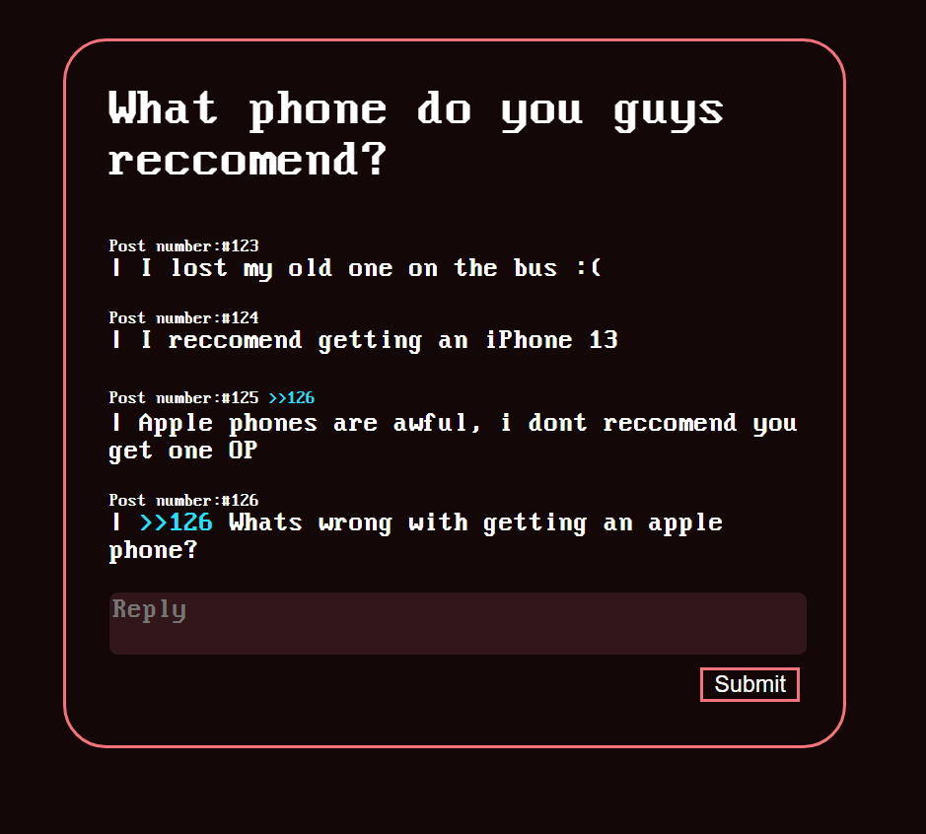

*This figure shows an example of what a thread would look like.*